**Practical No. 1**

**Aim:** SOAP Webservices

**Steps:**

Step 1: Create a new web application

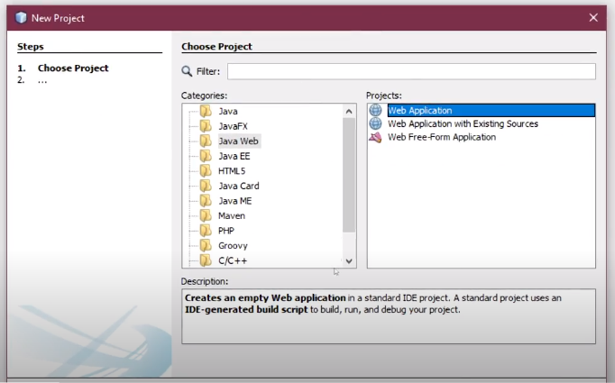

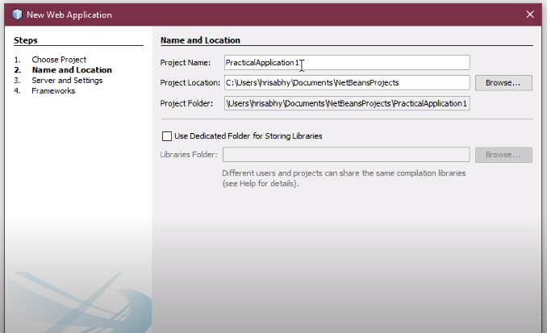

Step 2: Right click on your project then select New -> Web service. Give the web service and package a name.

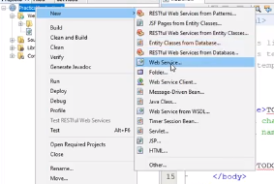

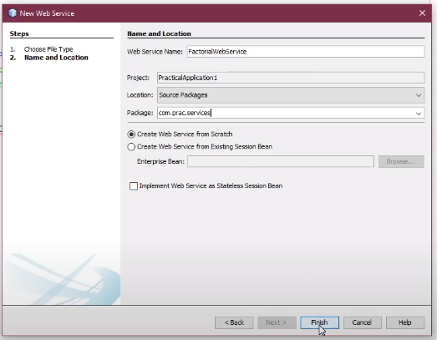

Step 3: Right Click on the web service and click on add operators or go to design and then click on add operators as shown below

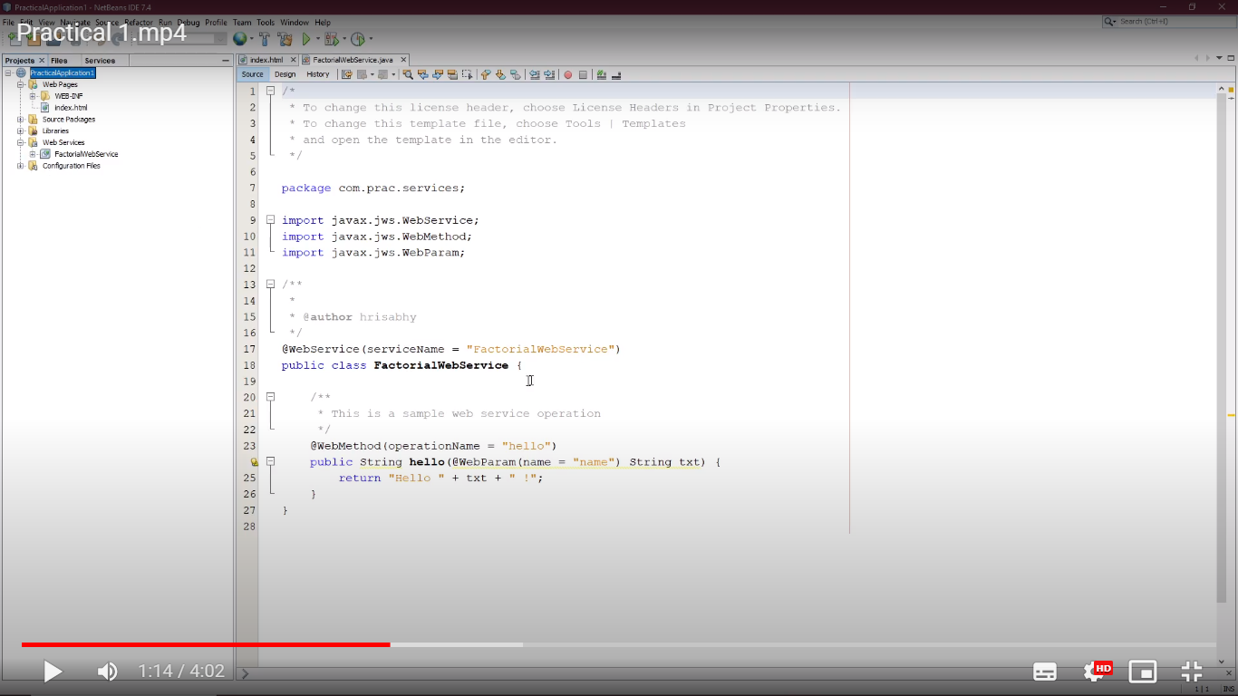

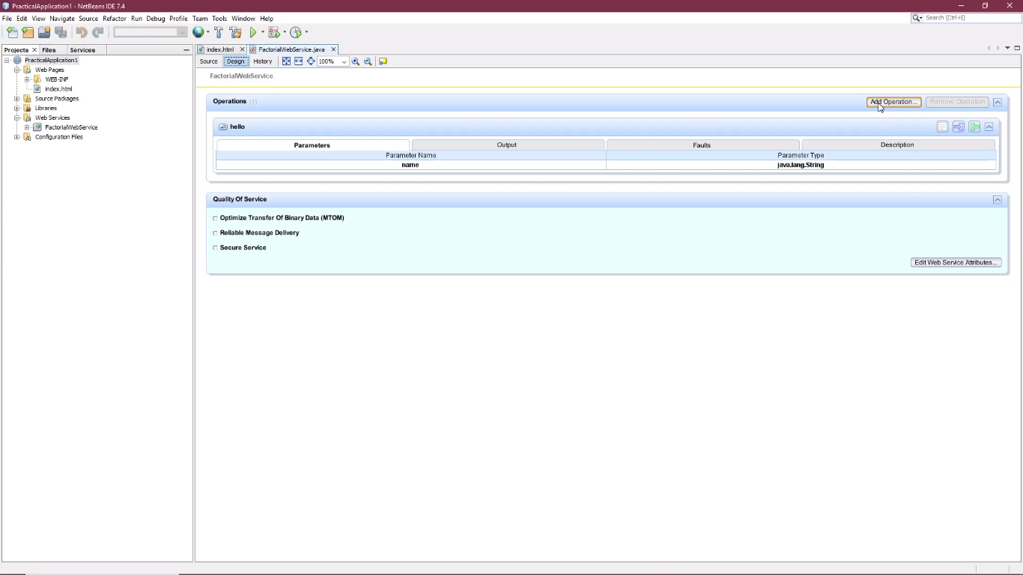

Step 4: add a new operator give it a name and set its Return Type to java.lang.Integer and then add a parameter num with type integer(int)

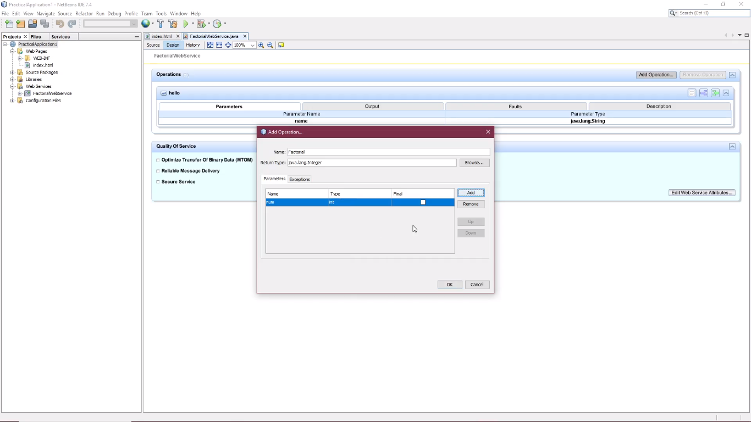

Step 5: you will see a new operation added in the web service, now add the following code.

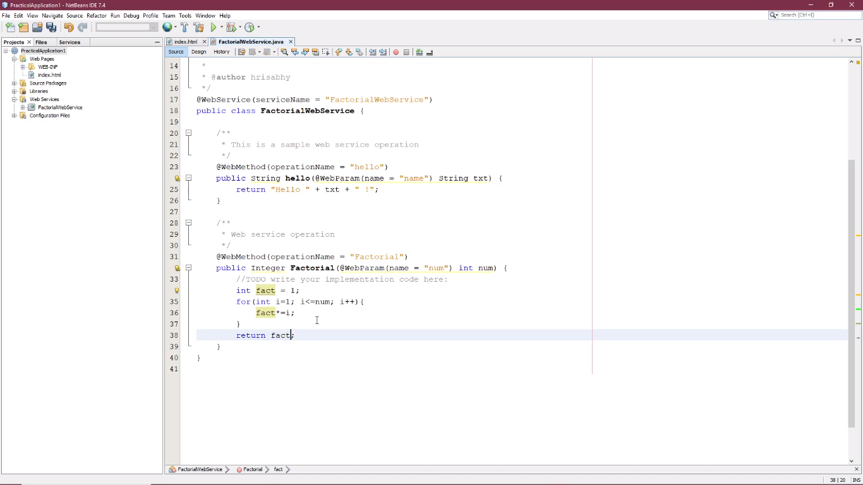

Step 6: Right Click on application/Project and click on Build, after a clean build then click on deploy

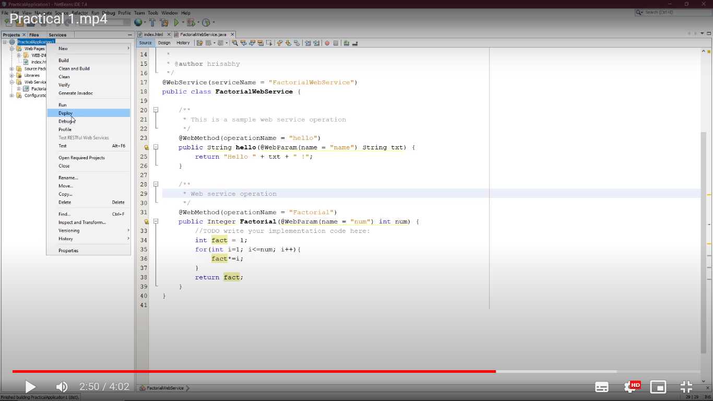

Step 7: Right click on the Web service and click on Test Web Service

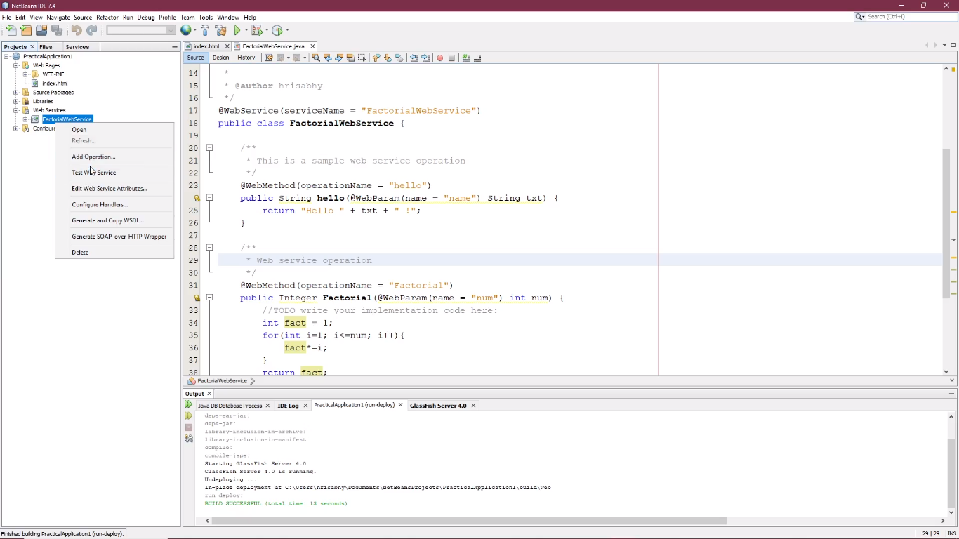

Output:

